## Use Cases

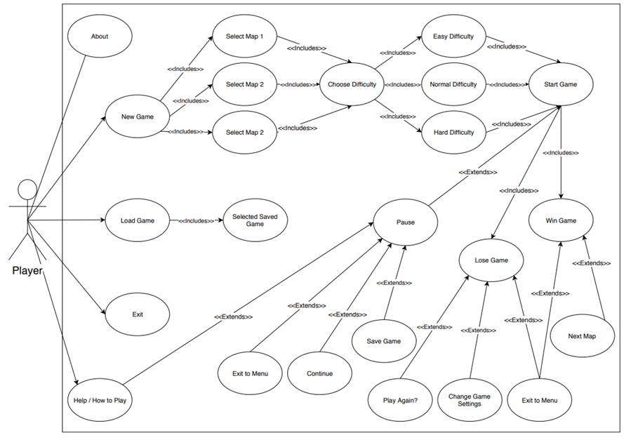

## Process and states of the game

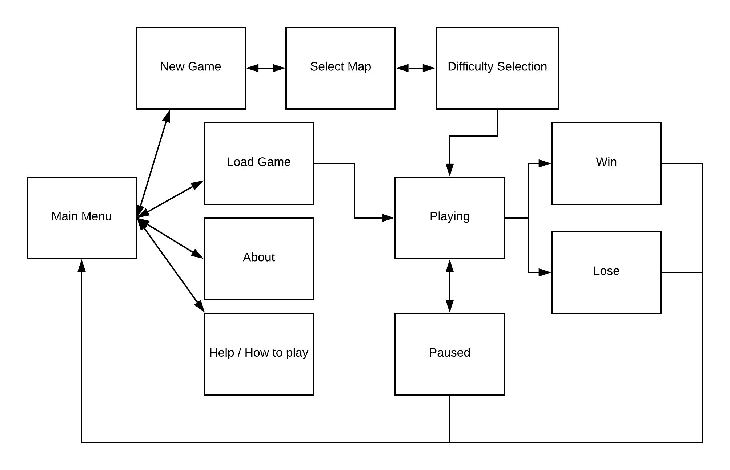

The above diagram shows the states in which the games will be in. You can see that when you access the main menu, you can create a new game, load the game, go to the about screen and final the help screen. Once you are on all these states, you can go back to the main menu. However, if you proceed onto another state, for example, the playing state, you are not able to navigate directly back to the main menu without pausing the game, winning the game or losing the game.

## User interface

|  |  |
| --- | --- |
| This is the main menu state. When you start the game. This is the first thing you’ll see. As you can see you will have access to:   * New Games * Loading old games * Document on how to play the game * About screen * Settings menu |  |
| The how to play menu will go into detail about not only how to play the game, but it will also show you how to be much better. You can revert to the main menu by pressing the bottom left button. |  |
| The settings menu will have technical settings and options that you might want to select. A darker coloured button will mean that setting is active, whereas a light button will mean that setting is off or inactive. For example, in the picture you will see that fullscreen is on and vsync is off. The music is set to 33% as you can see from the slider and the sfx is set to 78%. This is clarified by the label on the button too. |  |
| This is the about menu which shows what the game is about and who developed the game. |  |
| The player selects the difficulty of the game here. They’re also able to revert to the main menu. |  |
| The selection of the map is here, they have 3 choices (and might be given more in the future), there is also an endless mode which selects a special map. |  |
| This is the playing state of the game. This shows the path that the enemies will go down in on the field. The enemies will start from the top left and finish at the bottom left. Anywhere where the grass is on the grid, you will be able to place turrets. As you can see, turrets are on the field. |  |
| This is the playing state of the game again, but this is taken with the GUI minimised. When you press on the button, it will create the menu shown on the next page. |  |
| This is the GUI maximised. The button functionality works like so:   * X (closes the GUI) * T1 (places turret tier 1) * T2 (places turret tier 2) * T3 (places turret tier 3) * £ (sells) turrets * Pause (pauses the game) |  |
| The game is paused here, and you can choose to resume the game, save the game and quit to the main menu. Movements of the enemies and bullets will stop as well as the shooting of turrets. Time will also not increase in endless mode |  |